**HỌC VIỆN QUỐC TẾ FPT**

FPT-ACADEMY INTERNATIONAL

_____________________________________________________

**Wonder Travelling**

**Development’s Guide**

**Faculty: …**

**Batch No: …**

**Group No: 1**

**Student:**

|  |  |  |
| --- | --- | --- |
| **No** | **Full Name** | **Roll No** |
| **1** | **Duong Dinh Vu** | Student921581 |
| 2 | Pham Phan Nhat Khanh | Student920469 |
| 3 | Dieu Van Toan | Student912384 |
| 4 | Pham Dang Khoa | Student924942 |

Contents

REVIEW 2 3

1. Data Flow Diagrams 4

2. Use Case Diagrams 4

4. Entities Relationship Diagrams 4

4.1. Entities 4

5. SQL Tables 4

5.1. Relationship 4

5.2. Tables 4

5.2.1 Car 4

5.2.2 CarPrice 4

5.2.3 CarBrand 5

5.2.4 CarOption 5

5.2.5 Tours 5

5.2.6 TourDetail 5

5.2.7 Schedule 6

5.2.8 TourCategory 6

5.2.9 Booked 6

5.2.10 TourBookedDetails 7

5.2.11 CarBookedDetails 7

5.2.12 Customer 7

5.2.13 Role 8

5.2.14 Promotion 8

5.2.15 Review 8

5.2.16 ReviewDetails 8

6. Flow Chart 9

REVIEW 2

# Data Flow Diagrams

# Use Case Diagrams

1. **Sequence Diagrams**

*User Search Car

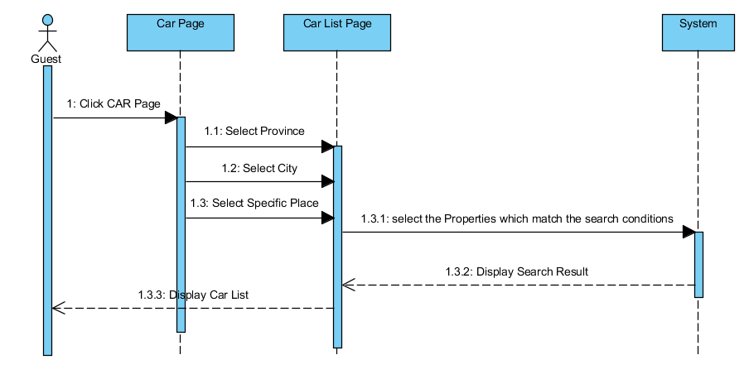

*User Booking Car

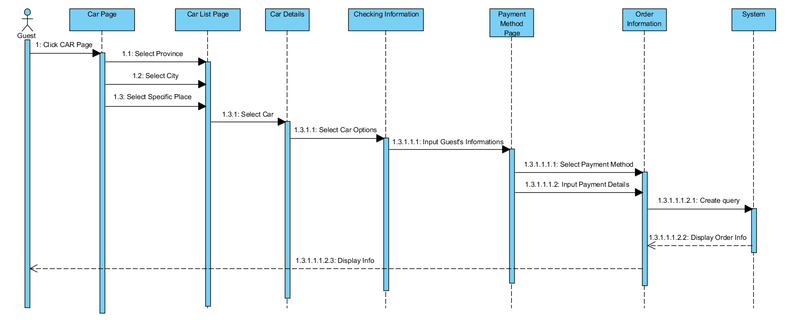

*Admin Add New Car

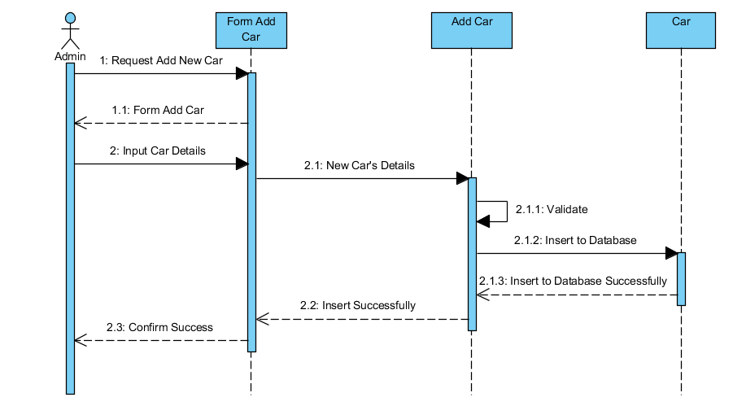

*Admin Edit Car

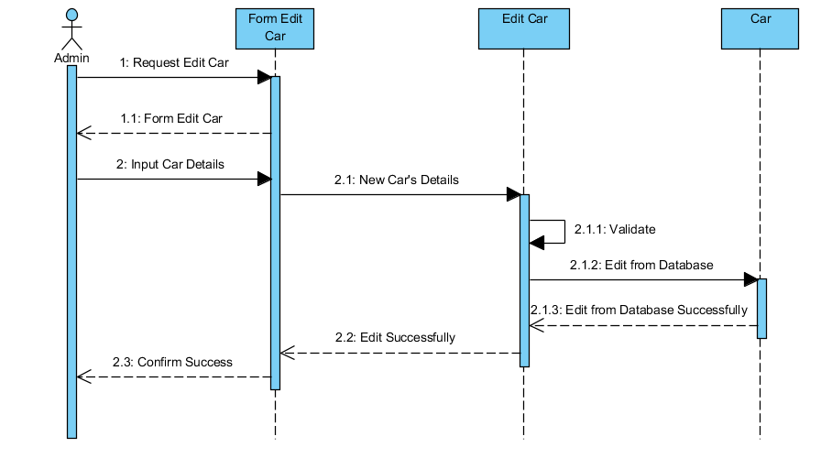

*Admin Delete Car

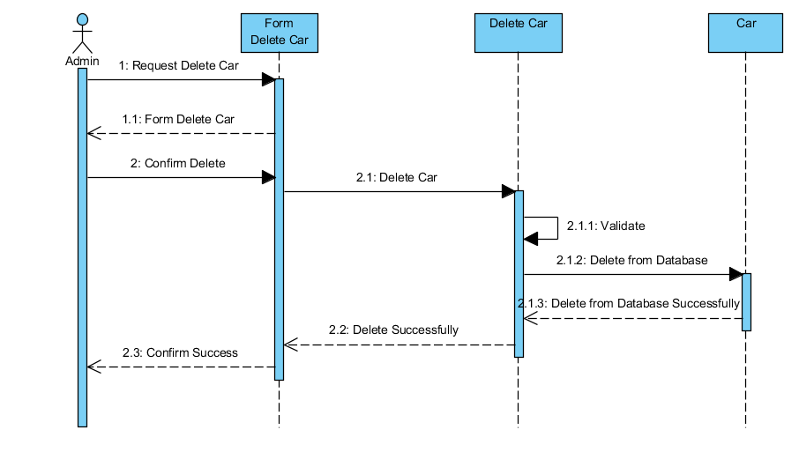

*Admin Create New Tour Category

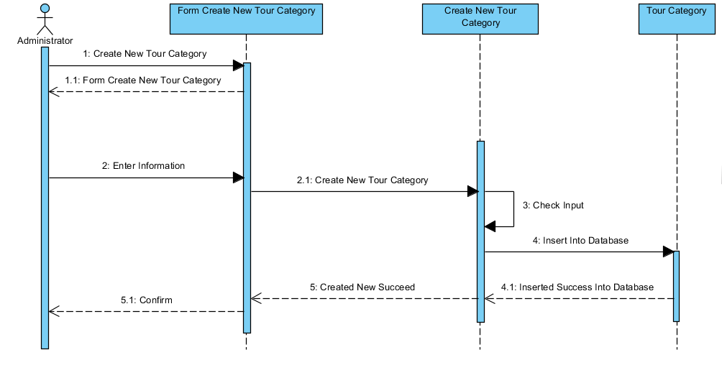

*Admin Update Tour Category

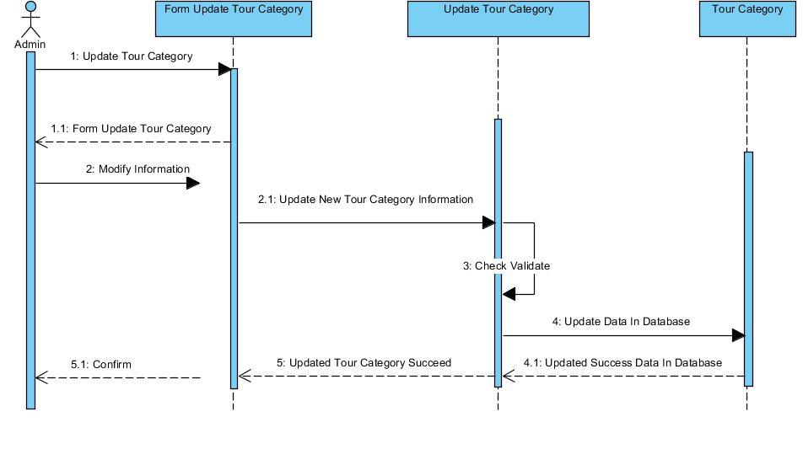

*Admin Create New Tour

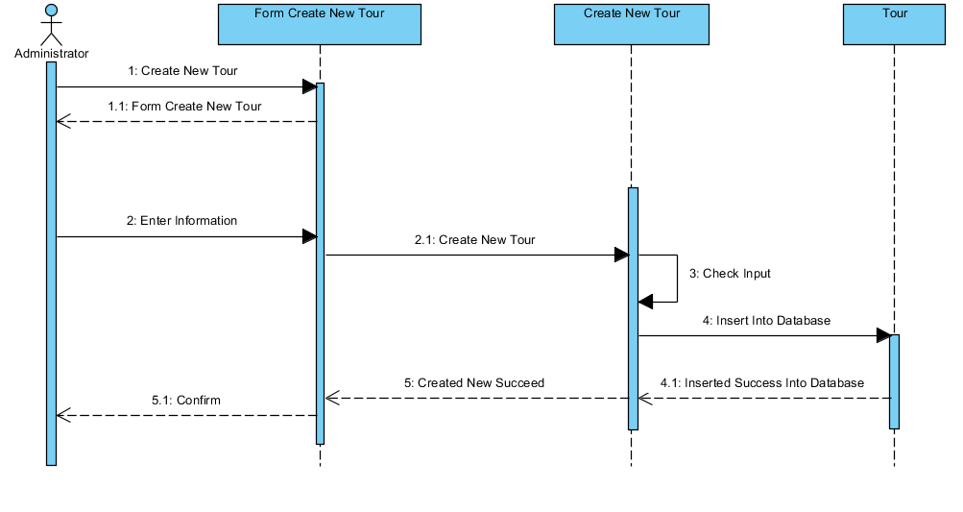

*Admin Update Tour

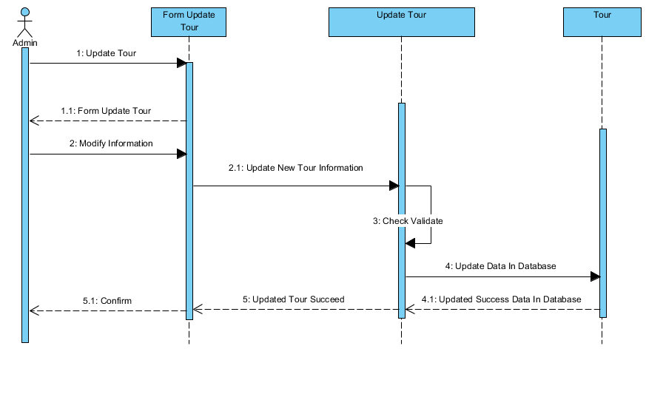

*Admin Delete Tour Category

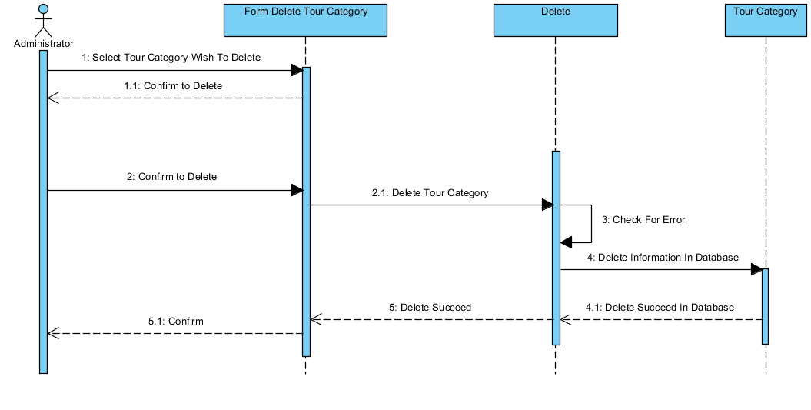

*Admin Delete Tour

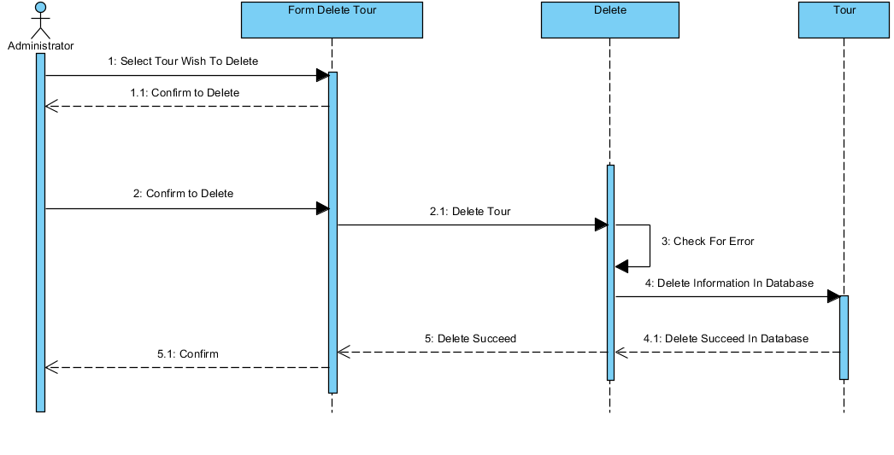

*Admin Search Tour

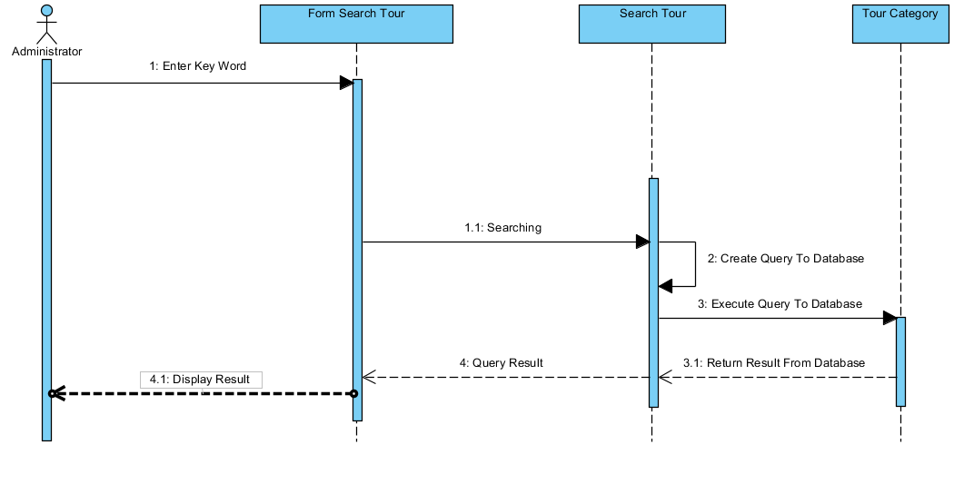

*Admin Search Comment

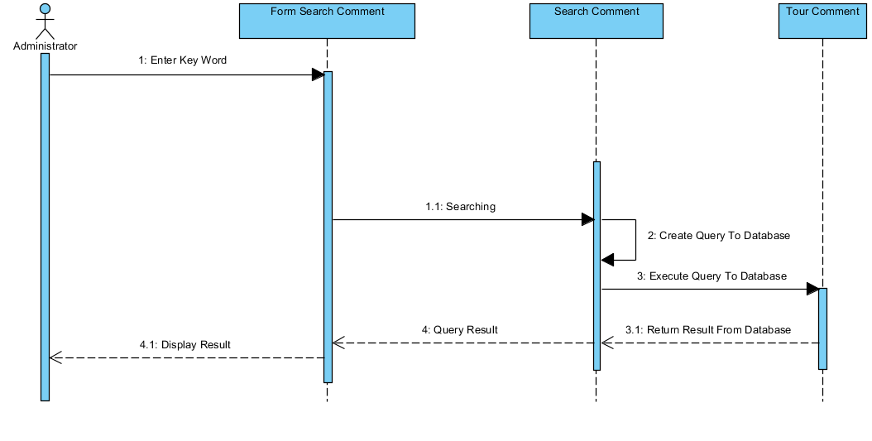

# Entities Relationship Diagrams

## Entities





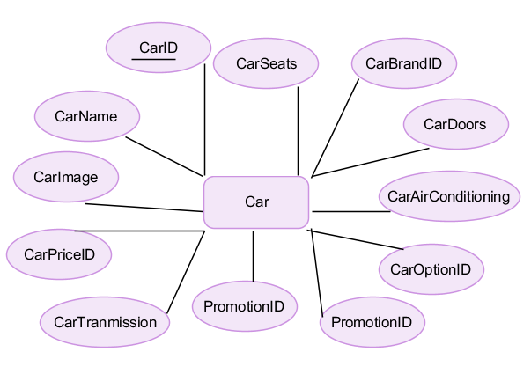

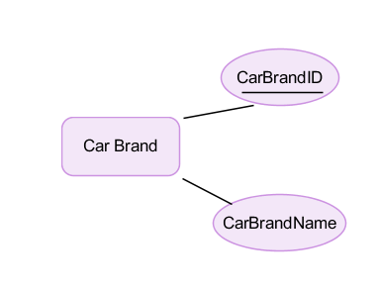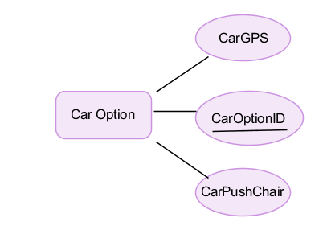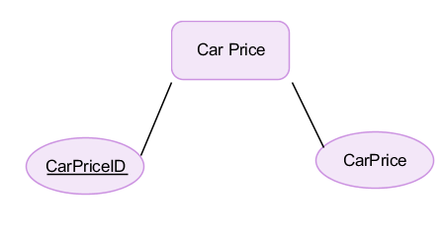

# SQL Tables



## Relationship

## Tables

## 5.2.1 Car

|  |  |  |  |  |  |  |  |
| --- | --- | --- | --- | --- | --- | --- | --- |
| **Key** | **Field Name** | **Data Type** | **Length** | **Allow Null** | **Default value** | **Table-Field-Ref** | **Description** |
| PK | **CarID** | int |  | No |  |  | Car ID |
| FK | CarBrandID | int |  | No |  | CarBrand.  CarBrandID | Car Car Brand ID  FK of Car Brand table |
| FK | CarPriceID | Int |  | No |  | CarPrice.  CarPriceID | Car Car Price ID  FK of Car Price table |
| FK | CarOptionID | int |  |  |  | CarOption.  CarOptionID | Car Car Option ID  FK of Car Option table |
| FK | PromotionID | Int |  | Yes |  | Promotion  PromotionID | Promotion ID  FK of Promotion table |
|  | CarName | varchar | max | No |  |  | Car Name |
|  | CarImage | varchar | max | No |  |  | Car Images |
|  | CarTranmission | varchar | max | No |  |  | Car Transmission |
|  | CarAirConditioning | varchar | max | No |  |  | Car Air Conditioning |
|  | CarDoors | int |  | No |  |  | Numbers of car doors |
|  | CarSeats | Int |  | No |  |  | Numbers of car seats |
|  | CarStatus | bit | 1 | No | 0 |  | Status of Car  0: Deactivate  1: Available |

## CarPrice

|  |  |  |  |  |  |  |  |
| --- | --- | --- | --- | --- | --- | --- | --- |
| **Key** | **Field Name** | **Data Type** | **Length** | **Allow Null** | **Default value** | **Table-Field-Ref** | **Description** |
| PK | **CarPriceID** | int |  | No |  |  | Car Price ID |
|  | CarPrice | float |  | No |  |  | Car Price |

## CarBrand

|  |  |  |  |  |  |  |  |
| --- | --- | --- | --- | --- | --- | --- | --- |
| **Key** | **Field Name** | **Data Type** | **Length** | **Allow Null** | **Default value** | **Table-Field-Ref** | **Description** |
| PK | **CarBrandID** | int |  | No |  |  | Car Brand ID |
|  | CarBrandName | varchar | max | No |  |  | Car Brand Name |

## 5.2.4 CarOption

|  |  |  |  |  |  |  |  |
| --- | --- | --- | --- | --- | --- | --- | --- |
| **Key** | **Field Name** | **Data Type** | **Length** | **Allow Null** | **Default value** | **Table-Field-Ref** | **Description** |
| PK | **CarOptionID** | int |  | No |  |  | Car Option ID |
|  | CarGPS | bit | 1 | No | 0 |  | Car Add-on  0: None  1: Have |
|  | CarPushChair | Bit | 1 | No | 0 |  | Car Add-on  0: None  1: Have |

## Tours

|  |  |  |  |  |  |  |  |
| --- | --- | --- | --- | --- | --- | --- | --- |
| **Key** | **Field Name** | **Data Type** | **Length** | **Allow Null** | **Default value** | **Table-Field-Ref** | **Description** |
| PK | **TourID** | varchar | Max | No |  |  | Tour ID |
| FK | PromotionID | Int |  | Yes |  | Promotion  PromotionID | Promotion ID  FK of Promotion table |
|  | TourTitle | Nvarchar | Max | No |  |  | Title |
|  | TourCGID | Varchar | Max | No |  | TourCategory  TourCGID | Tour Category ID  FK of Tour Category table |

## TourDetail

|  |  |  |  |  |  |  |  |
| --- | --- | --- | --- | --- | --- | --- | --- |
| **Key** | **Field Name** | **Data Type** | **Length** | **Allow Null** | **Default value** | **Table-Field-Ref** | **Description** |
| PK | **TourDTID** | varchar | Max | No |  |  | Tour Details ID |
| FK | TourID | varchar | Max | No |  | Tours.  TourID | Tour ID  FK of Tours table |
| FK | ScheduleID | varchar | max | No |  | Schedule.  ScheduleID | Schedule ID  FK of Schedule table |
|  | EventTourPrice | varchar | max | No |  |  | Car Name |
|  | OddTourPrice | float |  | No |  |  | Unfilled tours |
|  | DepartureDate | Datetime |  | No |  |  | Departure Time |
|  | HotelRank | Tinyint |  | No |  |  | Rank of hotels |
|  | DeparturePoint | Nvarchar | Max | No |  |  | Departure Point |
|  | Destination | Nvarchar | Max | No |  |  | Destination |
|  | Transportation | Nvarchar | Max | No |  |  | Ways of transportation |
|  | Duration | Tinyint |  | No |  |  | Duration |
|  | MaximumTicket | Tinyint |  | No |  |  | Maximum number of tickets |
|  | Status | Varchar | Max | No |  |  | Tour Details Status |

## Schedule

|  |  |  |  |  |  |  |  |
| --- | --- | --- | --- | --- | --- | --- | --- |
| **Key** | **Field Name** | **Data Type** | **Length** | **Allow Null** | **Default value** | **Table-Field-Ref** | **Description** |
| PK | **ScheduleID** | varchar | Max | No |  |  | Schedule ID |
|  | Title | Nvarchar | Max | No |  |  | Title |
|  | Content | Nvarchar | Max | No |  |  | Maximum number of tickets |
|  | Image | Varchar | Max | No |  |  | Images |

## TourCategory

|  |  |  |  |  |  |  |  |
| --- | --- | --- | --- | --- | --- | --- | --- |
| **Key** | **Field Name** | **Data Type** | **Length** | **Allow Null** | **Default value** | **Table-Field-Ref** | **Description** |
| PK | **TourCGID** | varchar | Max | No |  |  | Tour Category ID |
|  | TourCGTitle | Nvarchar | Max | No |  |  | Title |
|  | Destination | nvarchar | Max | No |  |  | Destination |
|  | DurationFrom | Smallint |  | No |  |  | Beginning of the tour |
|  | DurationTo | Smallint |  | No |  |  | Ending of the tour |
|  | PriceFrom | Float |  | No |  |  | Price Min |
|  | PriceTo | Float |  | No |  |  | Price Max |
|  | Transportation | Nvarchar | Max | No |  |  | Ways of transportation |
|  | Status | Varchar | Max | No |  |  | Status |

## Booked

|  |  |  |  |  |  |  |  |
| --- | --- | --- | --- | --- | --- | --- | --- |
| **Key** | **Field Name** | **Data Type** | **Length** | **Allow Null** | **Default value** | **Table-Field-Ref** | **Description** |
| PK | **BookedID** | varchar | max | No |  |  | Booked ID |
| FK | CustomerID | varchar | max | No |  | Customer.  CustomerID | Customer ID  FK of Customer table |
|  | CreatedDate | Datetime |  | No |  |  | The date which customer begin to book tour |
|  | TourBookedDetails | Varchar | Max | Yes |  |  | Booked Tour. |
|  | CarBookedDetails | Varchar | Max | Yes |  |  | Booked Car. |

## TourBookedDetails

|  |  |  |  |  |  |  |  |
| --- | --- | --- | --- | --- | --- | --- | --- |
| **Key** | **Field Name** | **Data Type** | **Length** | **Allow Null** | **Default value** | **Table-Field-Ref** | **Description** |
| PK | **TourBKDTID** | varchar | Max | No |  |  | Tour Booking Details ID |
| FK | TourID | varchar | Max | No |  | Tours.  TourID | Tour ID  FK of Tours table |
| FK | BookedID | Varchar | Max | No |  | Booked.  BookedID | Book ID  FK of Booked table |
|  | NumberOfKid | Tinyint |  | No |  |  | Numbers of childrend between 3 and 12 years old |
|  | NumberOfBaby | Tinyint |  | No |  |  | Numbers of childrend under 3 years old |
|  | NumberOfPeople | Tinyint |  | No |  |  | Numbers of people in tours. |

## CarBookedDetails

|  |  |  |  |  |  |  |  |
| --- | --- | --- | --- | --- | --- | --- | --- |
| **Key** | **Field Name** | **Data Type** | **Length** | **Allow Null** | **Default value** | **Table-Field-Ref** | **Description** |
| PK | **CarBKDTID** | varchar | Max | No |  |  | Car Booking Details ID |
| FK | CarID | varchar | Max | No |  | Car.  CarID | Car ID  FK of Car table |
| FK | BookedID | Varchar | Max | No |  | Booked.  BookedID | Book ID  FK of Booked table |
|  | CarQuantity | Int |  | No |  |  | Numbers of booked cars per user. |

## CustomerUser

|  |  |  |  |  |  |  |  |
| --- | --- | --- | --- | --- | --- | --- | --- |
| **Key** | **Field Name** | **Data Type** | **Length** | **Allow Null** | **Default value** | **Table-Field-Ref** | **Description** |
| PK | **CustomerID** | Int |  | No |  |  | Customer ID |
| FK | RepresentativeID | Int |  | No |  | Customer.  CustomerID | Representative ID  FK of Customer table |
| FK | RoleID | Int |  | No |  | Role.  RoleID | Role ID  FK of Role table |
|  | CustomerUsername | Varchar | max | Yes |  |  | User’s username |
|  | Password | Varchar | max | Yes |  |  | Users password |
|  | Fullname | Nvarchar | max | No |  |  | Fullname |
|  | Phone | Varchar | max | No |  |  | Phone number |
|  | Email | Varchar | Max | Yes |  |  | User Email |

## Role

|  |  |  |  |  |  |  |  |
| --- | --- | --- | --- | --- | --- | --- | --- |
| **Key** | **Field Name** | **Data Type** | **Length** | **Allow Null** | **Default value** | **Table-Field-Ref** | **Description** |
| PK | **RoleID** | Int |  | No |  |  | Role ID |
|  | RoleName | Varchar | Max | No |  |  | Role Names |

## Promotion

|  |  |  |  |  |  |  |  |
| --- | --- | --- | --- | --- | --- | --- | --- |
| **Key** | **Field Name** | **Data Type** | **Length** | **Allow Null** | **Default value** | **Table-Field-Ref** | **Description** |
| PK | **PromotionID** | Int |  | No |  |  | Promotion ID |
|  | PromotionCode | Varchar | max | No |  |  | Promotion Codes |
|  | CreatedDate | Datetime |  | No |  |  | Day Create Promotion |
|  | StartDate | Datetine |  | No |  |  | Start of Promotion |
|  | EndDate | Datetime |  | No |  |  | End of Promotion |

## Review

|  |  |  |  |  |  |  |  |
| --- | --- | --- | --- | --- | --- | --- | --- |
| **Key** | **Field Name** | **Data Type** | **Length** | **Allow Null** | **Default value** | **Table-Field-Ref** | **Description** |
| PK | **ReviewID** | varchar | max | No |  |  | Review ID |
| FK | CustomerID | varchar | max | No |  | Customer.  CustomerID | Customer ID  FK of Customer table |
|  | CreatedDate | Datetime |  | No |  |  | The date which customer leave a review |

## ReviewDetails

|  |  |  |  |  |  |  |  |
| --- | --- | --- | --- | --- | --- | --- | --- |
| **Key** | **Field Name** | **Data Type** | **Length** | **Allow Null** | **Default value** | **Table-Field-Ref** | **Description** |
| PK | **ReviewDTID** | varchar | Max | No |  |  | Review Details ID |
| FK | ReviewID | varchar | Max | No |  | Review.  ReviewID | Review ID  FK of Review table |
| FK | CarID | Varchar | Max | No |  | Car.  CarID | Car ID  FK of Car table |
| FK | TourID | Varchar | Max | No |  | Tour.  TourID | Tour ID  FK of Tours table |
|  | Content | Nvarchar | Max | No |  |  | Content of review |
|  | Rating | Int |  | No |  |  | Rating |

**5.2.17 Tour_Category**

|  |  |  |  |  |  |  |  |
| --- | --- | --- | --- | --- | --- | --- | --- |
| **Key** | **Field Name** | **Data Type** | **Length** | **Allow Null** | **Default value** | **Table-Field-Ref** | **Description** |
| PK | **TourCTID** | varchar | 30 | No |  |  | Tour Category ID |
|  | TourCGTitle | nvarchar | 50 | No |  |  | Tour Category Title |
|  | Destination | nvarchar | 50 | No |  |  | Tour Destination |
|  | DurationFrom | Smallint |  | No |  |  | Smallest Tour Duration Allowed |
|  | DurationTo | smallint |  | No |  |  | Biggest Tour Duration Allowed |
|  | PriceFrom | float |  | No |  |  | Lowest Tour Price Allowed |
|  | PriceTo | float |  | No |  |  | Highest Tour Price Allowed |
|  | Vehicles | nvarchar | 100 | No |  |  | Sorts Of Vehicles Allowed |
|  | Status | nvarchar | 20 | No |  |  | Tour Category’s Status |

**5.2.18 Tours**

|  |  |  |  |  |  |  |  |
| --- | --- | --- | --- | --- | --- | --- | --- |
| **Key** | **Field Name** | **Data Type** | **Length** | **Allow Null** | **Default value** | **Table-Field-Ref** | **Description** |
| PK | **TourID** | varchar | 30 | No |  |  | Tour ID |
|  | TourCGID | varchar | 30 | No |  | Tour_Category(TourCGID) | Tour Category ID |
|  | TourTitle | nvarchar | 70 | No |  |  | Tour Title |

**5.2.19 Schudule**

|  |  |  |  |  |  |  |  |
| --- | --- | --- | --- | --- | --- | --- | --- |
| **Key** | **Field Name** | **Data Type** | **Length** | **Allow Null** | **Default value** | **Table-Field-Ref** | **Description** |
| PK | **ScheduleID** | varchar | 30 | No |  |  | Schedule ID |
|  | Title | nvarchar | 100 | No |  |  | Title |
|  | Content | nvarchar | max | No |  |  | Activity content in a specific duration or day |
|  | Image | varchar | 100 | Yes |  |  | Representation Image of a specific day or activity |

**5.2.10 TourDetail**

|  |  |  |  |  |  |  |  |
| --- | --- | --- | --- | --- | --- | --- | --- |
| **Key** | **Field Name** | **Data Type** | **Length** | **Allow Null** | **Default value** | **Table-Field-Ref** | **Description** |
| PK | **TourDTID** | varchar | 30 | No |  |  | Tour Detail ID |
|  | TourID | varchar | 30 | No |  | Tours  (TourID) | Tour ID |
|  | EvenTourPrice | float |  | No |  |  | Tour Price For Group Reserve Customers |
|  | OddTourPrice | float |  | No |  |  | Tour Price for Odd Reserve Customers |
|  | DepartureDate | nvarchar | 100 | No |  |  | Available Days To Departure |
|  | HotelRank | tinyint |  | No |  |  | Hotel Rank |
|  | DeparturePoint | nvarchar | 50 | No |  |  | Departure Place |
|  | Destination | nvarchar | 50 | No |  |  | Destination |
|  | Vehicle | nvarchar | 50 | No |  |  | Vehicle Used To Move To The Tour’s Destination |
|  | Duration | tinyint |  | No |  |  | Total Time The Tour Will Be Last |
|  | ScheduleID | varchar | 100 | No |  | Schedule  (ScheduleID) | Schedule |
|  | MaximumTicket | tinyint |  | No |  |  | Maximum Of Ticket Could Receive On A Tour |
|  | Status | varchar | 30 | No | Activating |  | Tour Status |

**5.2.21 SmallOddReserveTour**

|  |  |  |  |  |  |  |  |
| --- | --- | --- | --- | --- | --- | --- | --- |
| **Key** | **Field Name** | **Data Type** | **Length** | **Allow Null** | **Default value** | **Table-Field-Ref** | **Description** |
| PK | **SmallORTID** | varchar | 30 | No |  |  | Small Group Of Odd Reserve Customer’s ID |
|  | CustomerID | varchar | 30 | No |  | Customers  (CustomerID) | Customer ID |
|  | ReserveDate | datetime |  | No |  |  | Tour Reserved Date |
|  | DepartureDate | datetime |  | No |  |  | Departure Date |
|  | IsKid | tinyint |  | No |  |  | Number Of Kid between 5 To 12 Years Old |
|  | IsBaby | tinyint |  | No | 0 |  | Number Of Kid Under 5 Years Old |
|  | NumberOfPeople | tinyint |  | No |  |  | Number Of Customer |
|  | TourID | varchar | 30 | No |  | Tours  (TourID) | Reserved Tour ID |
|  | Status | nvarchar | 100 | No |  |  | Status Of Customer Group Reserved Tour |

**5.2.22 OddReserveTour**

|  |  |  |  |  |  |  |  |
| --- | --- | --- | --- | --- | --- | --- | --- |
| **Key** | **Field Name** | **Data Type** | **Length** | **Allow Null** | **Default value** | **Table-Field-Ref** | **Description** |
| PK | **OddRTID** | varchar | 30 | No |  |  | Odd Reserve Customer’s ID |
|  | TourID | varchar | 30 | No |  | Tours  (TourID) | Tour ID |
|  | CustomerID | varchar | 30 | No |  | Customers  (CustomerID) | Customer ID |
|  | SmallORTID | varchar | 30 | No |  | SmallOddReserveTour  (SmallORTID) | Small Group Of Odd Reserve Customer’s ID |
|  | IsKid | tinyint |  | No |  |  | Number Of Kid between 5 To 12 Years Old After Merged Into A Group |
|  | IsBaby | tinyint |  | No | 0 |  | Number Of Kid Under 5 Years Old After Merged Into A Group |
|  | NumberOfPeople | tinyint |  | No |  |  | Number Of Customer After Merged Into A Group |
|  | DepartureDate | datetime |  | No |  |  | Departure Date |
|  | Status | nvarchar | 100 | No |  |  | Status Of Customer Group Reserved Tour |

**5.2.23 EvenReservetour**

|  |  |  |  |  |  |  |  |
| --- | --- | --- | --- | --- | --- | --- | --- |
| **Key** | **Field Name** | **Data Type** | **Length** | **Allow Null** | **Default value** | **Table-Field-Ref** | **Description** |
| PK | **EvenRTID** | varchar | 30 | No |  |  | Group Of Reserve Customer’s ID |
|  | TourID | varchar | 30 | No |  | Tours  (TourID) | Tour ID |
|  | CustomerID | varchar | 30 | No |  | Customers  (CustomerID) | Customer ID |
|  | RerserveDate | datetime |  | No |  |  | Small Group Of Odd Reserve Customer’s ID |
|  | IsKid | tinyint |  | No |  |  | Number Of Kid between 5 To 12 Years |
|  | IsBaby | tinyint |  | No | 0 |  | Number Of Kid Under 5 Years Old |
|  | NumberOfPeople | tinyint |  | No |  |  | Number Of Customer |
|  | DepartureDate | datetime |  | No |  |  | Departure Date |
|  | Status | nvarchar | 100 | No |  |  | Status Of Customer Group Reserved Tour |

**5.2.24 RatingTour**

|  |  |  |  |  |  |  |  |
| --- | --- | --- | --- | --- | --- | --- | --- |
| **Key** | **Field Name** | **Data Type** | **Length** | **Allow Null** | **Default value** | **Table-Field-Ref** | **Description** |
| PK | **RatingID** | varchar | 30 | No |  |  | Rating ID |
|  | RerservedTourID | varchar | 30 | No |  | Tours  (TourID) | Reserved Tour ID |
|  | CustomerID | varchar | 30 | No |  | Customers  (CustomerID) | Customer ID |
|  | Title | nvarchar | 100 | No |  |  | Title Of Rating Content |
|  | Description | nvarchar | max | No |  |  | Content Of Rating |
|  | Status | Varchar | 20 | No | Valid |  | Status Of Rating |
|  | StarsRated | float |  | No |  |  | Number Of Star Rated |

# Flow Chart

*Add Car

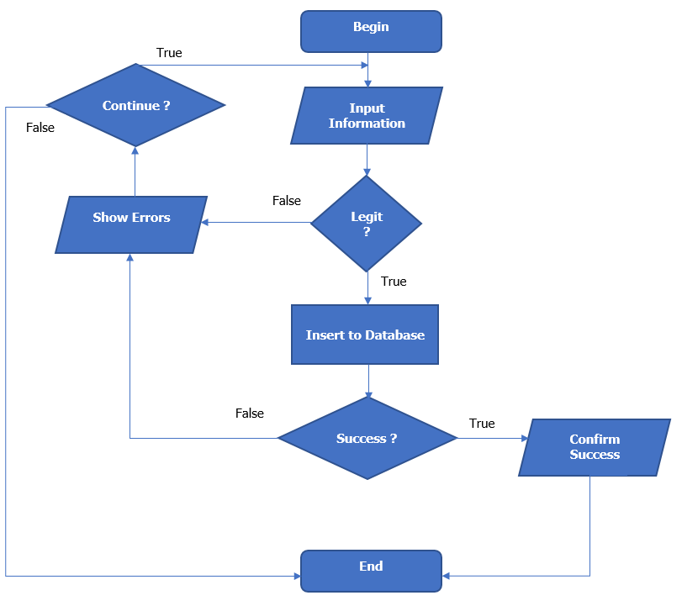

*Edit Car

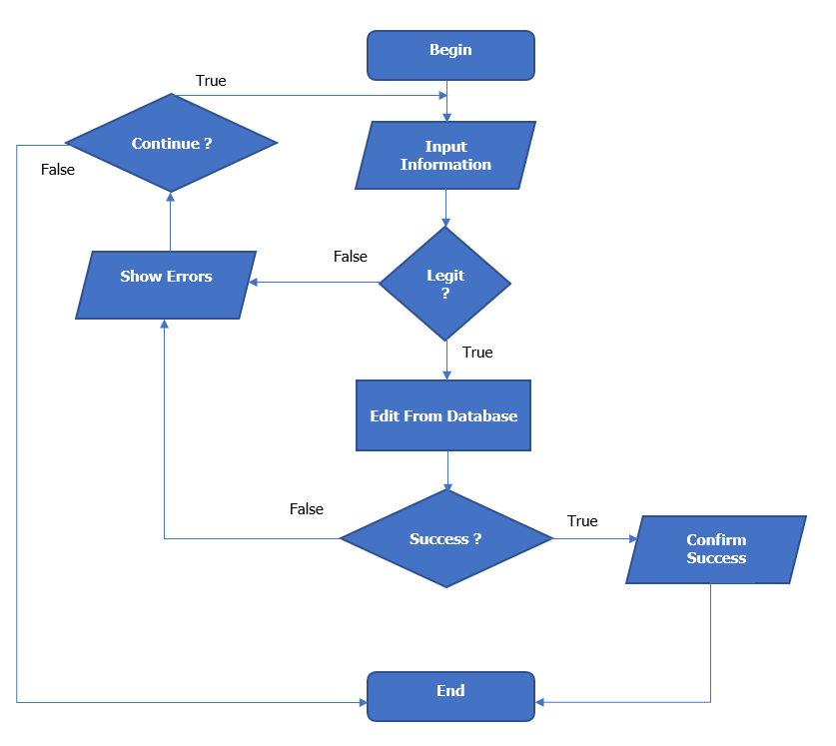

*Delete Car

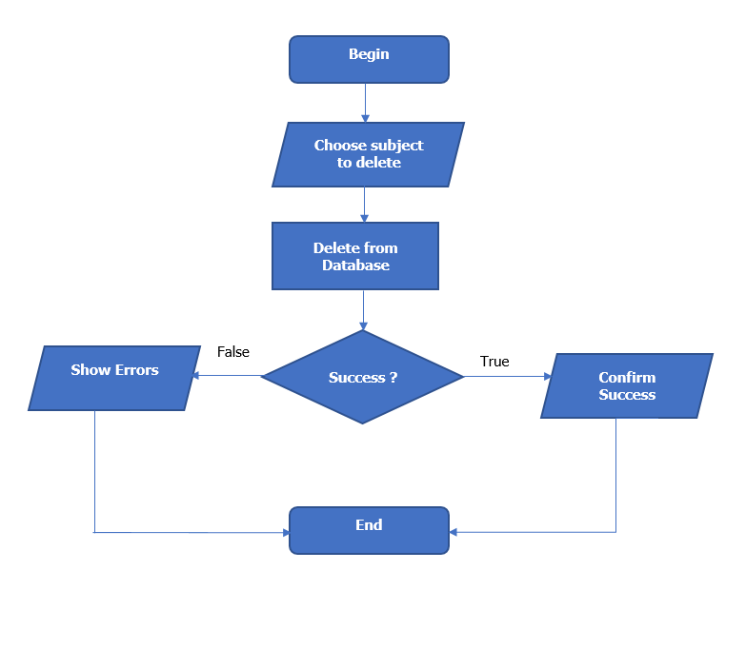

*Create Tour Category



*Update Tour Category

*Create Tour

*Update Tour

*Search Tour

*Search Comment

*Delete Tour



|  |  |  |
| --- | --- | --- |
|  | **Prepared by (Student)** | **Approved by (Faculty)** |
| **Signature** | Team leader  **Duong Dinh Vu** | **Phan Minh Tam** |
| **Date** |  |  |